Full paper title in title case (font: Arial 18 bold)

First Author ^{1 *}, Second Author ² and Third Author³

¹ Full address of first author, including affiliation and email
² Full address of second author, including affiliation and email
³ Full address of third author, including affiliation and email
(use Arial 10 typeface for author’s Affiliation)
*Corresponding authors, e-mail address: …

ABSTRACT

This file provides a template for writing papers for the conference. The conference proceedings will be published in an electronic format. The full paper file shall be written in compliance with these instructions. The author is asked to submit the paper in MS-Word and PDF Portable Document Format (PDF). Both files shall be saved with the full first author name as name of the file.
An abstract not exceeding 250-350 words, in English, should appear on the top of the first page, after the title of the paper in chapter titled "Abstract" (without chapter number), after the names of the authors and the contact information of the corresponding author.

Key Words: Maximum 6 Key words.

1. INTRODUCTION

It is expected that authors will submit carefully written and proofread material. Spelling and grammatical errors, as well as language usage problems, are not acceptable in the final submission. There is no strict limitation to the number of pages, but it is suggested that the paper length should not exceed 6000 words (15 pages).
Papers should clearly describe the background of the subject, the authors work, including the methods used, and concluding discussion on the importance of the work. Papers are to be prepared in English. Technical terms should be explained. Acronyms should be written out at their first appearance.
2. SUBMITTING THE Paper

The Full paper has to be submitted electronically by e-mail to the following addresses: tema-icnmsme2022.aveiro@ua.pt. And it should be submitted by 1 May 2022.

3. Paper format

The uniform outlook will help the reader to follow the proceedings. This can be obtained most easily if authors use this template file to construct their papers. Please note the following details: this template is an A4 format. All text paragraphs should be single spaced, with first line intended by 10 mm (0.4 inch). Double spacing should only be used before and after headings and subheadings as shown in this example. Position and style of headings and subheadings should follow this example. No spaces should be placed between paragraphs. Please do not change any of the above mentioned page, paragraph and font settings.

3.1. Fonts

Papers should use 11-point Arial font. The styles available are bold, italic and underlined.
It is recommended that text in figures is not smaller than 10-point font size.

3.1.1. Tables and Figures

Figure captions and table headings should be sufficient to explain the figure or table without needing to refer to the text. Figures and tables not cited in the text should not be presented. Styles Heading Table and Caption Figure are available in this template for tables and figures. The following is the example for Table 1.
Table1. Title of example table.
Standard Error | 20 Story |  |  |  | 30 Story
 | Uniform | ELF | SRSS | 3 Modes | Uniform | ELF | SRSS | 3 Modes
Displacement | 29.53 | 44.58 | 41.05 | 23.81 | 27.4 | 43.6 | 40.87 | 20.65
Drift | 60.4 | 60.92 | 60.47 | 38.24 | 60.91 | 63.83 | 63.53 | 26.19

Tables and figures should be placed close after their first reference in the text. All figures and tables should be numbered with Arabic numerals. Table headings should be above the tables. Figure captions should be centred below the figures. Minimum figures’ resolution: 150dpi.

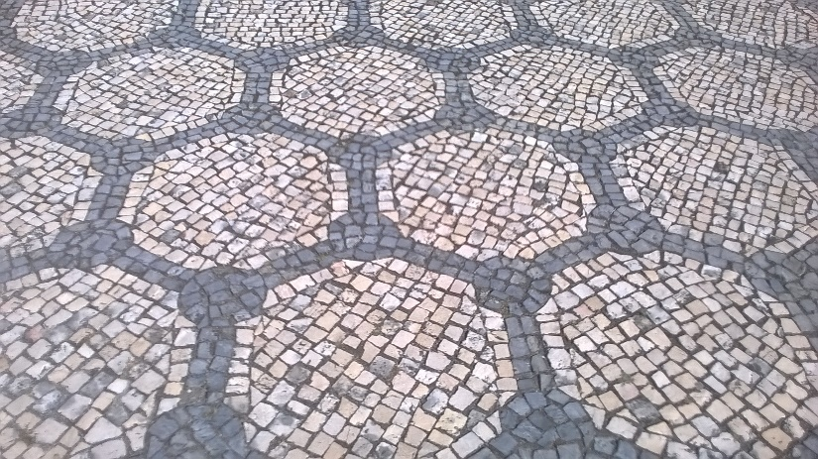
Figure 1. Stone mosaic.
ACKNOWLEDGMENTS

REFERENCES

Complete citations should appear at the end of the text. Use the reference style that is shown below for all references.

[1] J. Doe and R. Hill, J. Electrochem. Soc., 152, H1902 (2005). doi: …
[2] R. Smith, Electrochem. Solid-State Lett., 10, A1 (2007). doi: …
[3] E. Gaura and R. M. Newman, ECS Trans., 4(1), 3 (2006). doi: …
[4] D. Warren and J. M. Woodall, in Semiconductor Cleaning Technology/1989, J. Ruzyllo and R. E. White, Editors, PV 90-9, p. 371, The Electrochemical Society Proceedings Series, Pennington, NJ (1990).
[5] F. P. Fehlner, Low Temperature Oxidation: The Role of Vitrous Oxides, p. 23, Wiley Interscience, New York (1986).
[6] N. J. DiNardo, in Metallized Plastics 1, K. L. Mittal and J. R. Susko, Editors, p. 137, Plenum Press, New York (1989).

